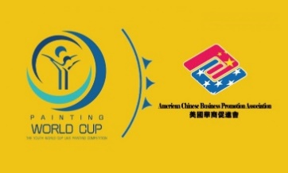 | THE 9TH YOUTH WORLD CUP PAINTING COMPETITION  2021 United States Section Registration Form  第九届世界杯青少年绘画大赛  2021美国赛区报名表

Contestant Information
Name: |  |  |  | Gen: | ❑ M ❑ F
 | First | Last | M.I.

Address:
 | Street Address | Apartment/Unit #

 | City | State | ZIP Code

Phone: |  | Email:

Day of Birth: | ( mm / dd / yyyy ) Age Group: ❑ 4-6 ❑ 7-12 ❑ 13-17 ❑ 18-25

Parent/Teacher/Organization Information
Name: |  | Relation:
Phone: |  | Email:
Mentor: | (if any) | Org: | ACBPA

Painting Information

Painting Name: |  | Category: | e.g. Oil Painting

Theme (Check Only 1 Box): | ❑ Dream ❑ Friendship ❑ Environmental Protection

Disclaimer and Signature
All prize-winning paintings shall be retained by Organizing Committee who also has the right to use the contestants’ photos. The final interpretation of the specific issues of the competition belongs to the Organizing Committee.
I certify that, to the best of my knowledge and belief, the information provided are true and correct.
(If you are not older than 18, please ask your parents or guardian to sign for this form.)
Signature: |  | Date:

THE 9TH YOUTH WORLD CUP PAINTING COMPETITION
2021 United States Section

Scheduling
1) Registration
Registration time: 9/1/2021 - 11/20/2021

2）Off-site Competition
Contestants need to submit a digital version of the work and pay an application fee of $50.
Winning contestants in the US section will need to submit the original work.
The deadline for artwork submission is 11/30/2021.
Winning works will be announced in December 2021.

3）United States Section Live Painting and Global Live Painting Contest
Due to the impact of the pandemic, the actual arrangements for the live competition and the global live finals are subject to change by the organizing committee. Contestants who place in the top 30% will be granted a reserved seat in next year’s Global Live Painting Contest.

Requirements
1）This competition is divided into four groups:
Group A: Preschool group (4-6 years old),
Group B: Children group (7-12 years old),
Group C: Juvenile group (13-17 years old),
Group D: Youth group (18-25 years old).

2) Artwork Requirements
1. Theme of works: friendship, dreams, environmental protection.
2. Introduction of works: less than 200 words in English.
3. Expression: No restrictions on expression, contestants may use any painting tools or materials.
4. Painting style: No restrictions
5. Drawing paper size: 18 in. x 14 in. or 18 in. x 12 in., horizontal or vertical.
Criteria and Awards
 | Theme | Creativity | Color | Technique | Composition
Percentage | 20 | 20 | 20 | 20 | 20

Awards:
1) All contestants will be awarded honorary certificates issued by the Canadian Art Development Fund, UNICEF, and the World Cup Youth Painting Competition Organizing Committee.
2) In the United States, laptops, tablets, and other electronics will be awarded to the first, second, and third/honorable mention prize winners respectively. The top 30% placing contestants will be eligible to compete in the global finals.
3) The global finals awards include a first prize (computer and 10000 ART coins), second prize($100 gift card and 50000 ART coins), third prize($50 gift card and 20000 ART coins), single prizes (best technique, best creativity, best color, best composition) and honorable mention prizes($50 gift card and 20000 ART coins).
4) Winning works are eligible for selection as annual outstanding works of the World Cup Painting Competition and the global tour exhibition.
Registration
- Fill in the registration form and pay the application fee.
Method 1: (USD payment) download the application form from the website: https://www.acbpa.com/painting-world-cup, fill out the registration form, pay with Zelle or check.
By Zelle ( Email: jefflouie2006@gmail.com, Jeff Louie )
By Check (payable to ACBPA, deliver to ACBPA)

Method 2: (RMB payment) use WeChat to scan the following code, register with cell phone, and use WeChat Pay to pay the application fee.
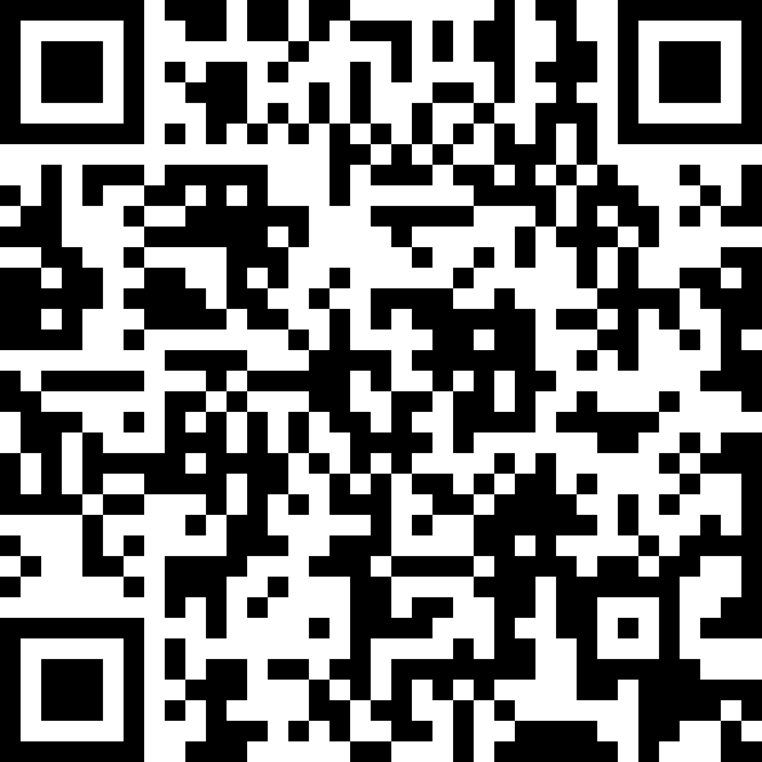
2) Submit Artwork (deadline: 10/31/2021)
A. Scanned copy of the entry (size not less than 1MB) (digital version)
B. Photograph of the work being held by the contestant (digital version)
C. Photograph of the contestant (digital version)
D. 200-word English version of the artwork description
E. Compress the items above into a folder and send to the emails of the organizing committee:
paintingworldcup2020@hotmail.com
3) In order for winning contestants in the US to participate in the global finals, entries must be mailed to the Organizing Committee.

Reminders
1. Once registered, the entry fee will not be refunded.
2. Entries must be original, non-plagiarized works that have not been submitted in other competitions.
3. Off-site competition entries (including but not limited to electronic photos, postal paper works, work statements, etc.) once submitted will be owned by the competition organizing committee and will not be returned.
4. Participants shall not transfer entries to third parties during the competition or permit third parties to use them. Without the authorization of the organizer, no individual or organization may use the works of this contest for any commercial purpose.

第九届世界杯青少年绘画大赛美国赛区章程

第一章 赛程安排
（一）参赛报名
报名时间：2021年9月1日-2021年11月20日
（二）非现场赛
选手需要提交一幅作品的电子版，并缴纳报名费50美元。如胜出，需提交作品原件。
作品征集截止日期为2021年11月30日，获奖作品公布时间为2021年12月。
（三）分赛区现场赛和全球现场总决赛
因疫情影响，现场赛和全球现场总决赛的实际安排请以组委会最新通知为准。可保留参赛者第九届大赛全球现场总决赛的入围资格。

第二章 参赛要求
（一）参赛年龄及组别
本次大赛分为幼儿组（4-6岁）、儿童组（7-12岁）、少年组（13-17岁）和青年组（18-25岁）四个组别，分组别进行评选。
（二）参赛作品要求
1、作品主题：友爱、环保、梦想。
2、作品介绍：200字以内，英文（中文请加翻译）。
3、表现形式：不限制表现形式，可以使用任何绘画工具、材料来创作。
4、绘画风格：不限制绘画风格，写实、抽象、动漫等均可。
5、参赛画纸：尺寸：18 inch * 14 inch 或 18 inch * 12 inch，横版、竖版均可.
国画作品纸张尺寸同上，重量不作要求。

第三章 评选标准与奖项设置
（一）评选标准
参考项 | 主题 | 创意 | 色彩 | 技法 | 构图
百分比% | 20 | 20 | 20 | 20 | 20

（二）奖项设置
1）所有参赛选手都可以获得加拿大艺术发展基金、联合国儿童基金会、世界杯青少年绘画大赛组委会颁发的荣誉证书。
2）美国赛区设立实物奖品，设立一等奖（手提电脑和10万艺术币）、二等奖（$100购物卡和5万艺术币）、三等奖（$50购物卡和2万艺术币）和单项优秀奖（$50购物卡和2万艺术币）。推荐总分数前30%的选手作品进入参加全球总决赛。
3）全球总决赛奖项分为一等奖、二等奖、三等奖、单项奖（最佳技法奖、最佳创意奖、最佳色彩奖、最佳构图奖）和优秀奖。
4）获奖作品将有机会入选世界杯绘画大赛年度优秀作品集和全球巡展。

第四章 报名方式
（一）填写报名表
参赛选手可通过以下方式填写报名信息和支付报名费：
方式一：（美元支付）
登录网站，https://www.acbpa.com/painting-world-cup 下载和填写报名表，
使用Zelle支付或支票支付。
Zelle (Email: jefflouie2006@gmail.com, Jeff Louie)
Check (payable to ACBPA, deliver to ACBPA)
方式二：（人民币支付）微信扫码报名和微信支付报名费。

（二）提交参赛作品的电子版本 (截止日期为2021年11月30日)
作品提交要求：
A、参赛作品扫描件（大小不小于1M）(电子版)
B、选手手持作品的照片(电子版)
C、选手身份照片(电子版)
D、200字英文版的作品介绍
E、将压缩文件夹发送至组委会邮箱：
paintingworldcup2020@hotmail.com

（三）美国区的获奖作品，需要邮寄参赛作品原件，参加全球总决赛

第五章 其他注意事项
1、一经报名，参赛费不予退还。
2、本次参赛作品是参赛者近期原创作品，未曾在任何绘画比赛中使用过。如存在抄袭、非原创作品而造成相关后果，责任自负。
3、非现场赛参赛作品（包括不限于电子版照片、邮递纸质作品、作品陈述等）一旦提交，即为大赛组委会所有，不予返还。
4、参赛者在比赛期间不得将参赛作品转让给第三方，或许可第三方使用。任何个人或组织在未取得主办方授权的情况下，不得将本次大赛作品用于任何商业用途。

